Instruction manual

1. Download the code.
2. Install the environment of javafx and add the VM argument.
3. When you are running it, it will show “org.junit.jupiter.api doesn’t found”. Because I am using IntelliJ IDEA as the IDE, so I will use the solve method of IDEA. Find one of the test files, and then click the @Test, then type ‘alt+enter’ on your keyboard, choose  add Junit to class path, then it will be fixed.

4.After all these steps, find the MinesweeperView.java, and run it.

5.Basic UI view of the game

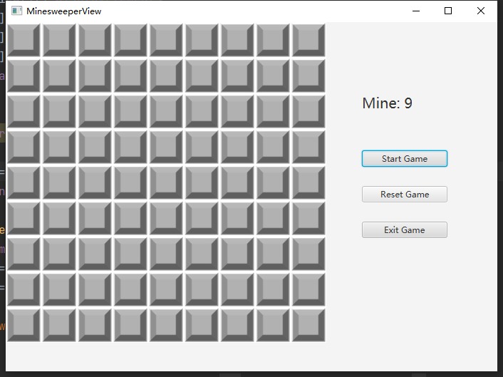

6.WOW factor:

we found some online resources to make it has some 3-D effect, also have special icons for the numbers and marking tags and mines, you will receive the notice when you put the marking tag.

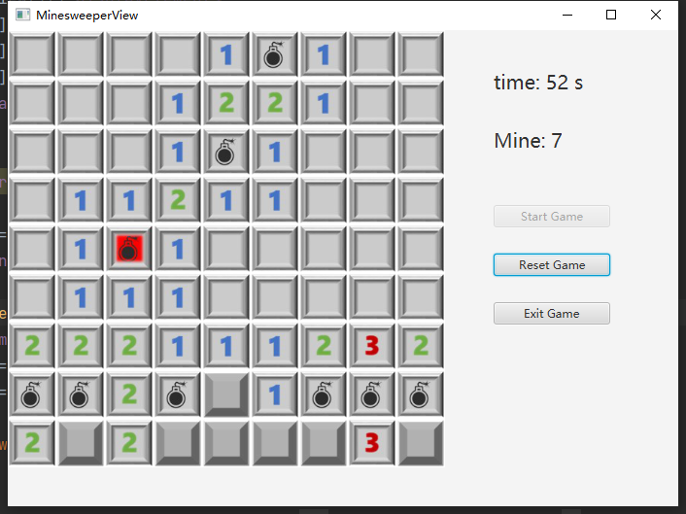

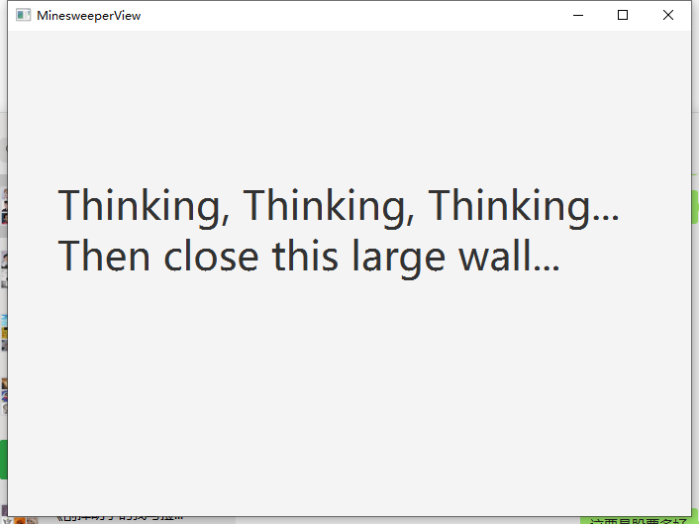

7.About save/resume

We do not put the save/resume button on the game board, but it has it. You can quit the unfinished game and when you reopen it again, you will find the status still same as you played last time.